**Statement of Work**

This Statement of Work ("SOW") by and between Cengage Learning, Inc. ("CL") and Interplay Energy, LLC ("Interplay") is subject to and incorporates by reference the provisions of the Master Services Agreement, dated June 20, 2014(the "Agreement"). Any capitalized term not defined herein shall have the meaning given it in the Agreement.

**1. Effective Date and Term**

This SOW is effective as of the last date found at the end of this SOW (the "Effective Date" of this SOW). The term of this SOW shall be for a period of eight years from product launch date and may be extended by mutual consent of the parties.

**2.** **Definitions**

*CL Content* (content, technology or other materials used by Interplay to fulfill obligations under this SOW): CL's textbook *Milady Standard Cosmetology*, 2016 Edition, and related ancillary and supplemental materials provided to Interplay during the term of the SOW.

*Interplay Materials* (preexisting content, technology, software, tools or other materials): The software platform, framework, content and delivery architecture comprising Interplay's training simulations.

**3. Description of Interplay Services**

***Background and Understanding***

Interplay develops 3-D interactive simulation training and testing applications for the professional trade workforce. CL is seeking a cost-effective, scalable solution to train hair care professionals on the primary cutting techniques.

Interplay has partnered with CL on other simulations including Delmar Online Training Simulation: HVAC, an HVACR training simulation based on the 7th edition of CL's textbook *Refrigeration and Air Conditioning Technology*.

This new interactive simulation, *Milady Online Haircutting Simulation (also referred to herein as the “Milady Simulation,” the “Simulation,” and the “simulation”),* will be based upon the 2016 edition of CL’s textbook *Milady Standard Cosmetology and the 2016 Milady Standard Haircutting System*.

All items delivered by Interplay under this SOW constitute “Deliverables” for purposes of the Agreement.

***Approach and Product***

Interplay is focused on delivering the following key outcomes:

* Provide a cost-effective simulation to train aspiring hair care professionals on the 4 primary cutting techniques in the core and the additional cuts as part of the Milady hair cutting system, with a maximum of five additional.
* Enable students unlimited practice with the hair cutting procedures in a realistic 3-D environment
* Build a simulation product that is both highly effective as a learning tool and highly marketable as a companion product to *Milady Standard Cosmetology*
* Provide instructors with an easy-to-use student tracking/assessment tool. This will allow instructors to assign engaging and easy-to-grade “lab” homework
* Curly Hair to be added as part of Year 2 product enhancement.

The simulation will be built around the concept of an immersive experience that mimics real world interaction in a salon. The aesthetics will match those of the Milady Standard for an attractive visual setting.

The simulation will feature an array of interchangeable variable sets that will challenge the hair care professional to master the primary hair cutting techniques. It will also feature an “Onboarding” section to familiarize students with the simulation interactions, as well as “Learning Modules” to integrate supporting learning activities and exercises.

The schematic below graphically depicts the core concept and key components of the simulation:

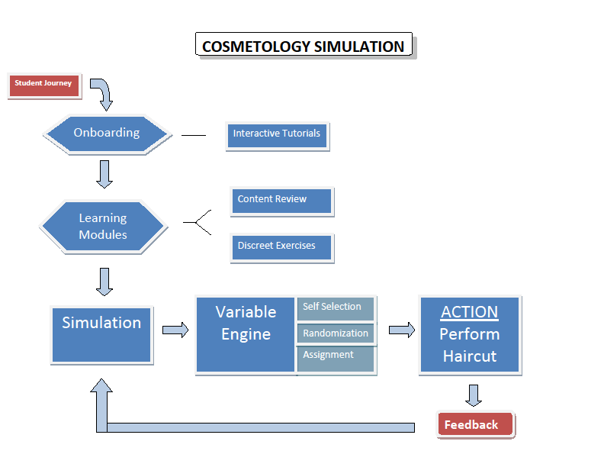

The simulation variable sets and action options are depicted in the graphic below. Because Interplay seeks to deliver a leading edge product, including simulation interactions that have not previously been developed by any entity in the marketplace, it is necessary to forecast the likelihood of inclusion of some of the more advanced features. See the color LEGEND below for the designations.

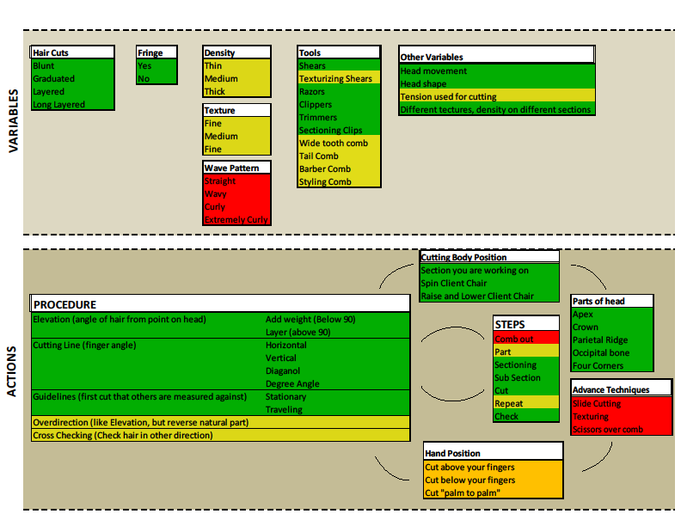

**Cross Checking**

**Overdirection**



Other Features or Options:

* Instructor reporting, assignment and gradebook functionality
* Gamification “achievements” and learning path
* Expected 30+ hours of “time on task”

Foundational Basis for Simulation:

* Primary text: *Milady Standard Cosmetology, 2016 edition*

***Technical Deployment***

The *Milady Simulation* product will be delivered via the web and available through browsers. (Graphic quality and file size may require a hybrid web-based/client version) The simulation will be operable on both Mac and Windows-based operating systems as well as tablet compatible for iPAD 3 or newer versions and primary Android devices (the final list of which Android makes/models is yet to be determined). Interplay will initially host all files on its servers. CL and Interplay will explore transitioning all files to CengageBrain. Interplay will utilize CL's existing Single Sign On API in order to support the use of CL SSO access codes which will provide a seamless login to Interplay. CL will provide the necessary technical assistance and any cost associated with the integration of *Milady Simulation* with CL SSO. Until otherwise designated, Interplay shall host the *Milady Simulation* on Interplay's servers and shall support the *Milady Simulation* in accordance with Exhibit C to the Agreement*.*

Interplay shall host the *Milady Simulation* on a state of the art high availability server farm utilizing load balancing and 24x7 URL monitoring. Interplay shall ensure that access to the simulation shall be available for access and use by end users at least ninety-nine percent (99%) of the time as measured over any one {1) year term of this Agreement, excluding any required scheduled maintenance, and any unavailable time due to a cause beyond the reasonable control of Interplay, such as, but not limited to, an unavoidable natural or man-made disaster. In the event of any downtime, Interplay shall contact CL's support coordinator via telephone and email alerting them to any issues within four {4) hours of any said downtime. CL shall advise Interplay as to the identity of CL's support coordinator. Interplay shall notify CL's support coordinator forty-eight (48) hours in advance of any scheduled maintenance and downtime. Interplay shall also provide CL's support coordinator on a quarterly basis a schedule containing dates and times of any planned maintenance or downtime.

***Access***

Students will access *Milady Simulation* individually via access codes to be issued and distributed by CL. CL will have the authority to decide access length for students. CL and Interplay agree to cooperate to insure that steps are taken to prevent license fraud when appropriate and necessary. CL, may, at its option and sole discretion, modify *the Simulation* prior to deployment and offer custom versions the *Simulation*, including modification of the duration of access, bundling or layering with other CL products or service, provided such modification and customization does not, without the prior approval of Interplay, impose any additional obligation upon Interplay.

Upon termination of this SOW, Interplay's obligations under this SOW shall cease, except that any CL customers who have, prior to termination, purchased or otherwise been given access to *the Simulation,*  may continue to access, and Interplay shall continue to host, the *Simulation* under terms of this SOW, for the duration of the period of time for which such customers have paid.

**4. Development Schedule and Methodology**

Estimated development time is 10 months from project initiation through completion. The graphic below depicts the different phases of the development. Material expansion of scope would alter this development schedule. Interplay absorbs all risk associated with development cost overruns.



Development methodology will be iterative. Cengage will be actively engaged in the project, including the incorporation of end-user customer testing and internal quality assurance reviews as appropriate.

**5. Fees and Expenses**

*Development Fees*

Total development cost will be Four Hundred Thousand US Dollars ($400,000.00), *including iPad and Android options.*

Cengage will be responsible for Two Hundred Thousand US Dollars ($200,000.00) of this cost. The remainder shall be borne by Interplay.

There will be 4 payments of Fifty Thousand US Dollars ($50,000.00) as follows:

* Fifty Thousand US Dollars ($50,000.00) upon acceptance of Initial Planning Document and Stage 1 Art
* Fifty Thousand US Dollars ($50,000.00) upon acceptance of Milestone 1, a Working 3D Environment
* Fifty Thousand US Dollars ($50,000.00) upon acceptance of Milestone 2, a Working Sim/Demo for Product Marketing
* Fifty Thousand US Dollars ($50,000.00) upon acceptance of final product

***Royalties***

i) Except as otherwise provided herein, with respect to the sale of access to the Milady Online Haircutting Simulation, CL shall pay a royalty as provided below, based on the Net Sales by CL, or any entity directly or indirectly controlling, controlled by or under common control with the CL (an “Affiliate”), from the sale of access codes to such Simulation, with it being understood that the term “sale” shall mean distribution of access by any means, including sale, license, subscription and rental in any form, format or medium. "Net Sales" shall mean gross sales of access codes to the Simulation (or, if CL sells access codes to the Simulation together with any other item or items at a single undistinguished price, the portion of the gross sales for such single price sale that CL reasonably attributes to the Simulation)during the applicable Calendar Year, less any credits or refunds for returns.

Calendar Year 2015:

30%

Calendar Year 2016:

25%

Calendar Year 2017:

20%

Calendar Year 2018 and Beyond

15%

For the purposes of clarification and to avoid confusion, the Calendar year is the 12 month period following product launch.

Without attempting to define or limit any other rights it may have under this Agreement, CL expressly reserves the right to, in its sole discretion, fix or alter the prices at which access the Simulations shall be sold. Sales of access to different Interplay Simulations shall not be aggregated for purposes of the royalty thresholds set forth above.

ii) No payment shall be paid on complimentary copies of the Simulation furnished to Interplay or to third parties, including, without limitation, copies furnished for advertising, review or sales/promotional purposes.

iii) ***Payments; Reporting***. CL shall report semi-annually on the distribution of the Simulation within sixty-five (65) days of the end of June and December each year during the term of this Agreement. With each report, CL shall make payment for the balance shown to be due. If the balance due Interplay for any settlement period is less than fifty dollars ($50.00), CL will make no payment until the next settlement period at the end of which the cumulative balance has reached at least fifty dollars ($50.00).

Any overpayment of fees due to returns, and any advances, grants or amounts of any nature that Interplay may owe CL, whether under this Agreement or otherwise, shall be retained for CL's own account from all royalties or other payments otherwise due Interplay under this Agreement between Interplay and CL.

**IN WITNESS WHEREOF**, the parties hereto have caused this Statement of Work to be effective as of June 20, 2014.

CENGAGE LEARNING, INC.INTERPLAY ENERGY, LLC

By: By:

Name: Name:

Title: Title: